**Cryoplant installation completed for ITER Neutral Beam Test Facility**

[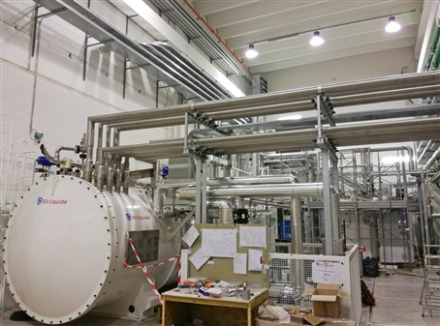](https://f4e.europa.eu/Downloads/News/07_Mitica_web_3_80802019-080820191200-Large.jpg)

F4E and Air Liquide bring cooling power to MITICA experiment.

​Another truck drives through the gates of Italy's National Research Council in Padua, heading towards the premises of Consortium RFX. More equipment is on its way to MITICA (Megavolt ITER Injector and Concept Advancement) – an experiment which will test the potential of a Neutral Beam Injector (NBI) prototype similar to that of ITER. Engineers involved in this field of work will test powerful heating systems which will be manufactured to raise the temperature of the super-hot plasma of the biggest fusion device. To maintain the vacuum in the vessel of MITICA, and to cool down its cryogenic pump, a cryoplant will be required, which is one of the many components provided by F4E to this experiment. Other parties contributing to the MITICA are Consortium RFX, ITER Japan and ITER Organization.

View on the top of the main cold box and interconnecting cryolines, ITER Neutral Beam Test Facility, MITICA, Padua, Italy

F4E in collaboration with Air Liquide have successfully completed the installation of the MITICA cryoplant. This achievement paves the way for commissioning with tests foreseen until the end of the year. "The cryogenic plant equipment consists of the compressor, main and auxiliary cold boxes, atmospheric heaters and auxiliary equipment units installed on site. The equipment operates with 20 cryolines and 30 warm lines whose installation proved to be challenging, given the complex technical environment and its multiple interfaces. The installation team has successfully overcome all these hurdles, the end result looks very neat and I'm pleased to say that the task has been carried out in a very professional manner" explains Grigory Kouzmenko, F4E Technical Officer following the contract.

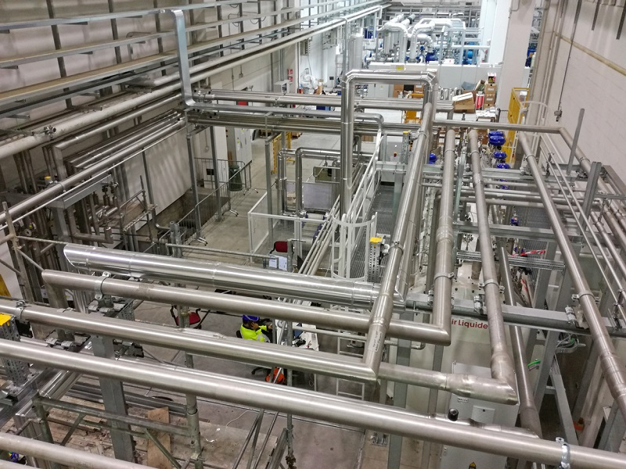

Cryolines connecting the main cold box with the auxiliary cold box, ITER Neutral Beam Test Facility, MITICA, Padua, Italy

Pre-commissioning checks of the equipment and interconnections are being finalised. The first equipment cooldown is expected in autumn 2019 and the complete cryoplant will be handed over to Consorzio RFX early in 2020.

The cryoplant will supply helium at -196 °C to cool down the thermal shields. It will also cool down the cryopanels, which will absorb the gas used to neutralise the high-energy beams, at -269 °C. To extract any gas captured by the cryopanels the system is periodically regenerated, circulating warmer gas at room temperature or at 127 °C through the cryopanels.